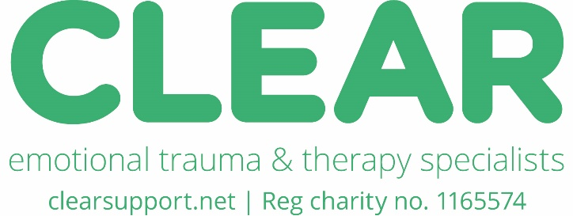
Job Description
Role Title | Clinical Lead – Children and Young People’s Trauma Recovery Service
Salary | £40,000 - £43,750 according to qualifications and experience (pro-rata)
Term | Permanent
Hours | Minimum 3 days (22.5 hours per week). Days and hours flexible. At least 2 days will be office-based.
Location | Truro
Post reports to | CEO
Other Considerations | - Successful applicants will be required to have an Enhanced DBS check.  - Probation period of 6 months, with interim review after 3 months  - 28 days leave including bank holidays (pro-rata) In addition 2 week closure at Christmas and 1 week at Easter.  - CLEAR is committed to workforce wellbeing and ensuring Continued Professional Development

Job Role and Purpose
You will lead CLEAR’s Children and Young People’s Trauma Recovery Service to deliver support for Children and Young People that is effective, safe and delivered to the highest professional standards, ensuring out continued accreditation with the BACP.

You will be responsible for the clinical work, operational processes, support and compliance of a team of employed and sessional therapists.

As part of the senior leadership team, you will support the strategic development of the charity and represent CLEAR in relevant strategic and operational partnerships and collaborations. You will also support service innovation and development, including a proposed move to an age-based model of 3 Clinical Service Leads.
You will report to the CEO and be supported by a Referrals Manager and Referrals/Office Administrator and works collaboratively with a Clinical Psychologist in the Evaluation and Quality Lead role across all of CLEAR’s services.

Key attributes
You will be a competent, collaborative and trauma-informed leader, a champion of children’s rights and have an in-depth understanding of trauma and its impact on children and young people.
You hold professional accreditation that meets BACP criteria for holding overall clinical responsibility or be working towards this.
You will be compassionate and resilient, mindful of your own self-care and that of your colleagues. You will be organised, able to balance competing demands and a good communicator to a wide range of audiences.
Key Responsibilities
- Develop and deliver the annual Service Delivery Plan for the CYP trauma-recovery service, feeding into the strategic planning cycle of the charity and ensuring services are delivered to budget.
- Ensuring the voice and needs of children and young people are foremost in service development
- Oversight and management of clinical work and processes, building effective teams and working relationships, ensuring the children’s service is delivered in line with the BACP Ethical Framework and trauma-informed principles.
- Ensuring the highest standards of clinical practice are maintained in line with BACP, HCPC, UKCP and other relevant professional frameworks
- Line management of employed therapists, including regular 1-2-1s
- Support and management for sessional self-employed therapists, including compliance and bi-annual contract reviews
- Supporting the Continuous Professional Development of therapists, linking this to operational need and opportunities to develop CLEARs services
- Ensuring compliance with CLEAR policy, procedure and process and high standards of clinical governance within the CLEAR database.
- Ensuring SARs and police requests and court orders for session notes, are responded to in a timely manner, in line with CLEAR policy.
- Working with the Evaluation and Quality Lead in the development and implementation of clinical evaluation measures.
- Working with the Evaluation and Quality Lead to ensure reporting to funders is provided in line with the requirements of contracts and grant agreements.
- Oversee Safeguarding for the service, assess risk for clients and therapists, and ensure that relevant policies, training and feedback/protocol is documented
- Attend appropriate internal and external meetings to build and maintain excellent partnerships and systems approaches.
General Duties
- To foster excellent effective communications throughout the service both internally and externally.
- To be responsible for own continuing self-development, undertaking training as appropriate.
- Participate in recruitment and induction of new staff as appropriate.
- To undertake any other tasks deemed necessary so that the service is effective and well managed

Person Specification: Skills, Knowledge and Experience:

Essential Skills, Knowledge and Experience | Desirable
Post Graduate Qualification in counselling/therapy/psychology or other relevant field which includes a strong foundation in child development and attachment theory.  Accreditation with relevant professional body or working towards accreditation | Clinical Psychologist/Child and Adolescent Psychotherapist  Qualification and experience of being a Child Clinical Supervisor
A minimum of 3 years of experience of working with children and young people affected by trauma, including domestic abuse and sexual violence | 5 years of experience working with children. Research experience and relevant qualification
Excellent understanding of safeguarding children and vulnerable adults | Safeguarding qualification, experience as Safeguarding Lead
Experience of leading and developing a service or major project | Leadership and Management or Project Management Qualification
Experience of line management and building successful teams | Experience of working across systems and building external partnerships
Good all round IT skills and use of Microsoft 365 applications | Experience of working with bespoke databases

How to apply: Please download and complete the CLEAR application form from our website https://clearsupport.net/team/job-vacancies
Return to info@clearsupport.net putting CYP Clinical Lead in the title of the email
Closing date for applications: Wednesday 10th December
Interviews will be held w/c 5th January and 12th January 2026

