What is Play Therapy?

Play Therapy is a specialised form of counselling or psychotherapy that is designed for children. Play is the natural form of communication for children. Children and young people, due to their stage of development or past traumatic experiences, often find it hard to express themselves fully through speech and, even if they could, the prospect of a ‘talking therapy’ may be frightening.

Within Play Therapy, the toys, musical instruments, and art resources act as your child’s ‘words’, enabling them to communicate their thoughts and feelings about what they have experiences in a way that offers them a sense of safety and distance from reality.

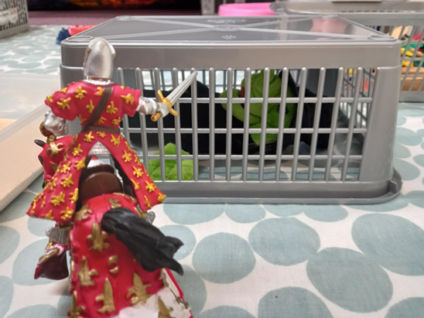

Early life trauma can often result in children developing false beliefs, particularly about themselves. Play Therapists are trained to look out for these ‘false beliefs’ and will look to find a way to help your child to let go of these, sometimes through the play and sometimes by incorporating stories and playful activities.

Each child’s life story is different and, even within families where siblings have lived through the same traumatic events, each child’s experience will be unique to them. A Play Therapist might look to offer your child support with you also in the sessions, or they may recommend that your child has individual therapy sessions and offer you guidance on how to support your child alongside their CLEAR sessions. The number of sessions that your family is offered might also affect how your CLEAR Play Therapist looks to best support your child.

Most parents or carers find that children benefit from Play Therapy support in one or more of the following ways:

- Their child has gained a sense of control and mastery over events that had previously left them feeling scared and confused.
- Their child has been able to make sense of what they have experienced, without carrying unnecessary blame and feelings of shame.
- Parents and Carers felt that they better understood how their child was feeling, felt more confident in knowing how to talk to their child about past events and respond empathically to trauma-related behaviours.
- Their child was better able to label and express their feelings in a more positive way.
- Their child’s trust in their parents or carers had strengthened.

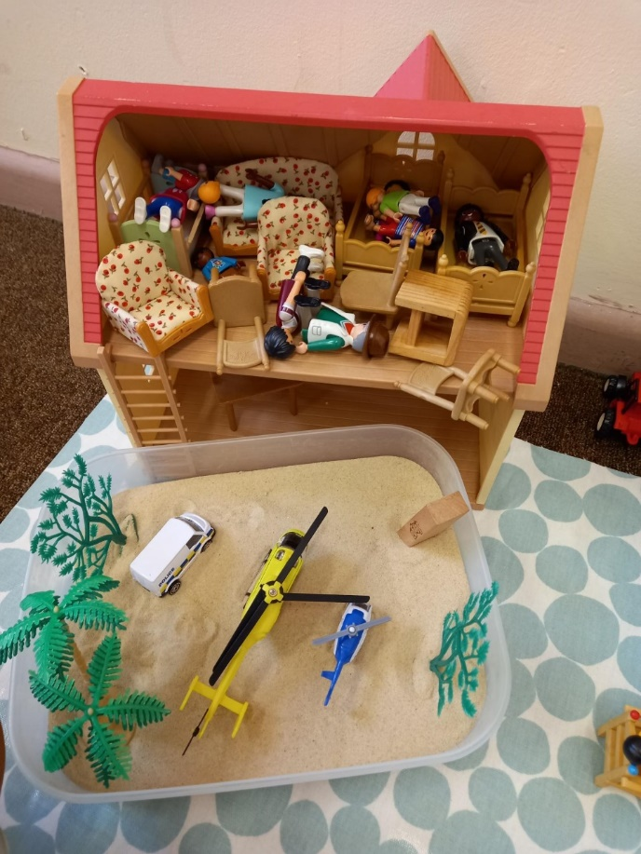

Most children between 4 – 11 years can benefit from Play Therapy. Play Therapy may also be appropriate for children slightly younger or older than this age range, depending on the individual’s development and needs.
​
​Play Therapy support is not always appropriate, and your CLEAR therapist will want to talk to you about your individual family situation, to make sure that Play Therapy would benefit your child. As with any therapeutic support, it is likely that your child might feel a little ‘wobbly’ in the first few Play Therapy sessions and this might result in a temporary increase in ‘challenging’ behaviours. Your Play Therapist will talk about these with you, some parents and carers might feel that they do not have the resilience to cope with their child responding to therapy in this way, in which case it might be other support rather than Play Therapy would feel more appropriate for your family. Similarly, if your family was about to undergo a significant change, e.g., your child was about to move house or school, your Play Therapist might advise you that your child needed to feel more settled before they begin any Play Therapy support.

​Having Play Therapy support from CLEAR offers you and your family the protection on knowing that your therapist has the appropriate qualifications, is registered with a professional organisation, and has experience of supporting families who have experienced trauma.
​
